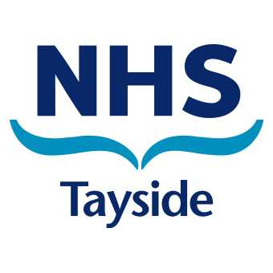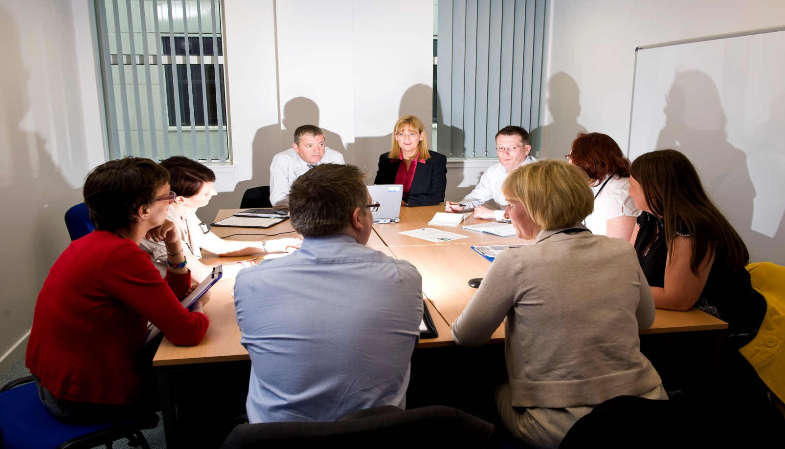

**Want to make a difference to the NHS in your local**

**community?**

**How do I find out more?**

An application pack and full details on this and other public appointments can be found at the public appointments website: www.appointed-for-scotland.org. **Completed applications must be received on or before MIDDAY on Wednesday 4th September 2019.**

 Appointments to Tayside NHS Board are regulated by the

Ethical Standards Commissioner

We are looking for people with a wide range of skills and backgrounds. You do not need to be an expert in health and/or social care.

If you believe that you have the experience and skills to take up this rewarding and challenging role, and are sensitive to the diverse needs of people and the health and care services which affect them, we would like to hear from you.

It is a commitment of 3 days per week for a remuneration of £33,446 per annum.

Scottish Ministers want to appoint a new non-executive **Chair** to **Tayside NHS Board.**

We want to hear from people with the senior level experience required for this significant appointment.

This is an exciting time of transformational change for NHS Tayside, designing and delivering changes which will improve performance and develop the capability and capacity to return NHS Tayside to its place as one of the most innovative and best performing Health Boards in the UK.

Can I apply?

How?