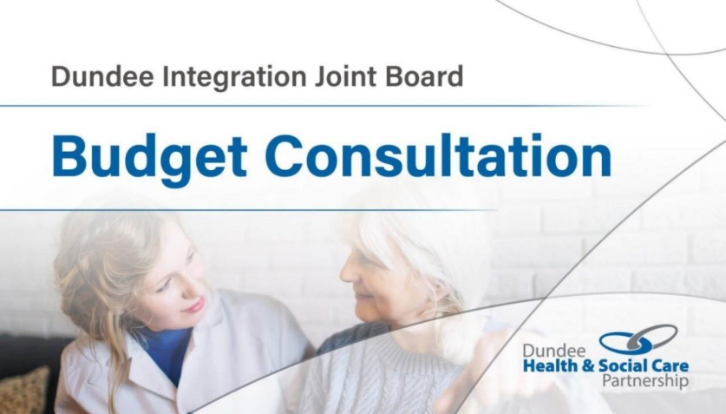

Facilitation Pack – IJB Budget Consultation 2026/27
Feedback from the first IJB Budget Consultation undertaken in February 2025 highlighted that a number of stakeholders would value a facilitation pack being developed to support them when developing a response on behalf of a group of people. This might be a group of people who all use the same service, a representative group based on a shared characteristic, interest or geography, or a team of staff working within a relevant service area. To support the 2026/27 Budget Consultation a facilitators pack has been developed that sits alongside the consultation survey.

Overview of the 2026/27 IJB Budget Consultation
The budget consultation will run from Tuesday 03 February to Tuesday 03 March 2026.
All stakeholders, including citizens, service users, unpaid carers, members of the workforce and partner organisations are encouraged to take part.
Three main routes to contribute are available:
- Online survey – available to anyone to respond. A copy of the survey is available here: Dundee IJB Budget Consultation - Resources. The survey can be complete Dundee Integration Joint Board (IJB) 2026/27 Budget Consultation
- Facilitated group discussion – supported by this pack and submitted via the online survey (Dundee Integration Joint Board (IJB) 2026/27 Budget Consultation – Fill in form).
- Consultation sessions – more information available at: Dundee IJB Budget Consultation | Dundee Health and Social Care Partnership.
A copy of the online consultation survey questions is available in full here: Dundee IJB Budget Consultation - Resources. This facilitation pack is aligned to the survey questions – supporting key information to be captured in a format that will allow a survey response to be completed following the group discussion. The pack is designed to be used by a wide variety of groups with different levels of knowledge and understanding of health and social care services and supports.

Facilitated Discussion – Suggested Session Plan
Introduction  (15 minutes) | Welcome everyone.  Explain the purpose – to share our views and contribute our voices to help shape how the budget for local health and social care services is spent.  Remind everyone that their voice and experience is valuable and important. Agree any rules about how participants want the session to run to make sure that everyone can have their say. Some common rules might be:  - Only one person communicates at once – when someone is sharing, everyone else listens.  - We respect each other's views and opinions, even if we do not agree with / share them.  - What is said in the group should stay in the group – group members will not discuss the detail of what has been said outwith the group.
What is most important to us...  (survey section 2)  (15 minutes) | When decisions are made about how to spend the health and social care budget choices have to be made – to spend more money on something means less has to be spent somewhere else.  These choices can be about how the money available is TARGETED. For example, should we spend more on doing what people need now at the cost of doing things that might prevent ill health in the future.  They can also be about how services are DELIVERED. For example, should more services be delivered online rather than in-person.  The IJB would like to know what is most important to you so it can consider this when deciding what to spend money on.  Share the sheet titled – What would you choose? (Appendix 1). Members of the group might want to have a short discussion about the options and their views prior to voting on the three most important options.  For each question ask people to tick/ put a coloured dot in the row next to the three things they think are most important to them.  If there are not 3 clear ‘winners’ for each question ask the group to either discuss and agree their top 3 from the highest voted options (or you can remove the lowest scoring options and vote again until you get to a top 3).
Impact on you…  (survey section 3)  (suggest 20 minutes per proposal discussed) | The number of savings proposals is significant – groups may therefore wish to agree which proposals they want to focus on rather than make a response to every proposal. A list of proposals is contained in Appendix 2 – this can be shared with the group to support a discussion to agree which proposals they will consider.  For each proposal the group wants to discuss a short explanation of the proposal, the reason for it, and how possible impacts might be mitigated is available here: Dundee IJB Budget Consultation - Resources.  A template for guiding the discussion about each proposal is contained in Appendix 3. This aligns to the survey format so that notes captured in the session can be easily transferred onto the electronic response form. The main focus is on understanding what would happen if this saving option went ahead – what would happen to people because of this change? What could be done to help people with those impacts?
What else is important?  (15 minutes)  (survey section 4) | Group members might have ideas about different, and better, ways that money can be saved. We want to hear any and all ideas that people want to share with us. These can be captured in the template in Appendix 4.  Appendix 4 also has space to capture anything else that people want to share that feels important to them.
Thank you  (5 minutes) | End the session by thanking everyone for their contributions. You can explain that the notes from the session will be shared with the IJB via an online form.

Submitting a response
The response from the session must be submitted via the online survey form. In exceptional circumstances copies of notes recorded on facilitation templates will be accepted but these must be in an electronic format (they cannot be handwritten) – this is to ensure that all responses are able to be accurately read / understood and recorded. Please contact dundeehscp@dundeecity.gov.uk or 01382 433410 to discuss submission options – please DO NOT email responses to this address as they will not be accepted.
The online form is available at: Dundee Integration Joint Board (IJB) 2026/27 Budget Consultation . Please only submit the response once you have gathered all of the information from your group – the submission is best completed in a single session (there is limited functionality to save and add to / revise it later). If your group is meeting several times to consider the different options please wait till the end of those meetings and submit a single response.
Please follow these guidance notes when completing the form:
- Question 1 – select the third option – On behalf of a group of people
- Question 2 – pick the option that is the best match
- Question 3 – select as many options as apply to your group.
- Question 4 – select the 3 answers with the highest number of votes from your group (Appendix 2 template).
- Question 5 – select the 3 answers with the highest number of votes from your group (appendix 2 template).
- Question 6 to 20 – complete the response based on the notes you have recorded in the Appendix 3 templates. For any proposals you did not discuss simply select the “prefer not to answer option”.
- Question 21 complete the response based on the notes you have recorded in the appendix 4 template.
- Question 22 – complete the response based on the notes you have recorded in the appendix 4 template.

Appendix 1 – What would you choose?
The IJB has a set amount of money to spend on health and social care services. It has to decide what is most important to spend that money on.

- TARGETING SERVICES – what are the three most important things the IJB should focus their spending on?

Keep services as good as they are now.

Make sure services help people in crisis right away.
Focus on preventing future health and care problems.
Prioritise people with the greatest need.

Support people who usually have the works health outcomes.
Help people stay independent in their community instead of going to hospital.
Make sure people leave hospital as soon as they are medically ready.
Provide support for unpaid carers (family and friends who care for others).
Promote early help and healthier lifestyles.

- DELIVERING SERVICES – what are the three most important things that the IJB should focus their spending on?
Services are close to where I live.

I can get the services I need quickly.

Services have flexible hours, including evenings and weekend.
I can access services online (appointments and groups).
I can see someone in person if I need to.

Services are provided by the Council and NHS (through the Health and Social Care Partnership), not the private or voluntary sector.
Services are free to use.

Appendix 2 – What Proposals do we want to discuss?

- Funding for specific organisations -From April 2026, the IJB could stop funding two organisations:
- Food Train – provides grocery deliveries and welfare checks for older adults. It currently receives £82,000 per year, which is 4% of the organisation's total income*.
- Bharatiya Ashram Lunch Club – provides culturally appropriate lunch clubs for older adults from black and minority ethnic communities. It currently receives £10,000 per year, which is 17% of the organisation’s total income*.
(*based on 2024/25 audited annual accounts)
- Reduction in funding for services delivered by the third and independent sector - From April 2026, the IJB could reduce funding to third and independent sector organisations delivering a range of health and social care services and supports up to 10% of the total value of current contracts (£46 million). This would affect services such as: support to unpaid carers; support for people with a learning disability and autism; mental health and wellbeing supports; Third sector infrastructure and capacity building; support for older people; support for people who use drugs and alcohol; independent advocacy; and, support for people who are homeless or at risk of homelessness. Services who are funded to provide Care at Home Services and Care Homes will not be affected by this proposal.

- Tayside Nutrition and Dietetics Service - The IJB could reduce funding for the Tayside Nutrition and Dietetics Service, with access criteria being changed and 5,000 fewer appointments being offered each year across Tayside. These appointments cover nutritional assessment and support, and the reduction would be spread across renal services, elderly medicine, paediatrics, and community care. (In the last 12 months the service has offered 22,000 appointments. A reduction of 5,000 appointments is therefore 22% of the current appointment levels).
- Review of Physiotherapy and Occupational Therapy - The IJB could change how it funds Physiotherapy and Occupational Therapy services. This means looking at the service in detail to find ways to save money — either by working more efficiently or by reducing some parts of the service. The review will focus especially on MSK Physiotherapy, the Specialist Falls Service, Specialist Neurological Rehabilitation, and the Community Rehabilitation Teams.

- Provision of Equipment – Occupational Therapy - The IJB could stop providing funding for the provision of certain items of equipment by the Occupational Therapy Service (shower boards, shower chairs, shower stools, perch stools and trolleys).

- Older People’s Mental Health Services – Weekend Services - The IJB could reduce funding for Mental Health Nurses who providweekend cover. This would mean:
- The Community Mental Health Teams (CMHT) for Older People East and West would no longer have Mental Health Nurses available on Saturdays and Sundays (09:00-17:00).
- The Care Home Team would also not have Mental Health Nurses available on Saturdays and Sundays (09:00-17:00).

- Review of The Corner - The IJB could change how it funds The Corner, a confidential health and information service for young people aged 11 and over. This would involve reviewing the service to find ways to reduce costs or increase funding from sources outwith the IJB. The review would look particularly at services for 20–26 year olds and for young people who live outside the Dundee area. It would also explore options for joint working with other young people’s services in Dundee.

Appendix 3 – How will the savings proposal impact on us?

Proposal number:

If this proposal happened the impacts will look / feel like:
What are the things that worry you about this proposal? If this proposal happens what will change for you and other people?

The impact would be less if:
What could be done to help people who with these things? What would make it better for them?

Overall, we think that this saving proposal will have:
No impact on us
A small impact on us (low)
A moderate impact on us (medium)
A big impact on us (high)

Appendix 4 – What are our other ideas and thoughts?
- If you were in charge of setting the budget, what other ideas would you consider?
Do you have ideas about what could be done that are not already included in the list of proposals? How would you save money? What would you think about spending less on in the future?

- Is there anything else that feels important to you that you think the IJB should be told?
This could be about how savings might impact people or anything else you think they need to think about when they are making decisions about how money should be spent.

